Simulation-Based Comparison of Controlled Interrupted Time Series and Multivariable Regression
${Fredrick Orwa}^{1}$,${Charles Mutai}^{1}$,${ldephonse Nizeyimana}^{1}$,${Ann Mwangi}^{1,2}$
$1_{Department of Mathematics,Physics,and Computing, Moi University, Kenya}$
$2_{The Academic Model Providing Access to Healthcare (AMPATH), Kenya}$

Table S1: Calculated $n_{sim}$ formulas for performance measures (The number of simulations was chosen using a pilot run of 100 simulations under the most restrictive setting ($n$=12,$ρ$ =0.8,effect size(small) =-0.0408), such that the Monte Carlo standard errors for bias, mean squared error, model-based and empirical standard errors were below 0.005, and those for coverage and power were below 0.5 percentage points).
Performance measure | Formula for number simulations required($n_{sim})$ | Number of simulations($n_{sim}$)
Bias | $\frac{\frac{1}{n_{sim-1}}\sum_{1}^{n_{sim}}{}{(\hat{θ_{i}}-\underline{θ})}^{2}}{{\left(\sqrt{\frac{1}{n_{sim\left(n_{sim-1}\right)}}\sum_{1}^{n_{sim}}{}{(\hat{θ_{i}}-\underline{θ})}^{2}}\right)}^{2}}$ | 8688
Mean square error (MSE) | $\frac{\frac{1}{n_{sim-1}}\sum_{i}^{n_{sim}}{}{\left[{(\hat{θ_{i}}-θ)}^{2}-MSE\right]}^{2}}{{\left(\sqrt{\frac{1}{n_{sim\left(n_{sim-1}\right)}}\sum_{1}^{n_{sim}}{}{\left[{(\hat{θ_{i}}-θ)}^{2}-MSE\right]}^{2}}\right)}^{2}}$ | 2827
Empirical standard error(EmpSE) | 1+$\frac{\hat{{EmpSE}^{2}}}{2{\left\{MCSE\left(\hat{EmpSE}\right)\right\}}^{2}}$ | 4345
Model-based standard error (ModSE) | $\frac{Var\left[\hat{Var\left(\hat{θ}\right)}\right]}{4\hat{{ModSE}^{2}}{\left\{MCSE\left(\hat{ModSE}\right)\right\}}^{2}}$ | 822
95% Coverage | $\frac{Coverage\left(1-Coverage\right)}{{\left(MCSE\left(Coverage\right)\right)}^{2}}$ | 1900
80% Power | $\frac{Power\left(1-Power\right)}{{\left(MCSE\left(Power\right)\right)}^{2}}$ | 6400
Here, MCSE denotes the desired Monte Carlo standard error and $ρ$ denotes lag-1 auto-correlation. Consequently, the largest required number of simulations (8,688) was selected.

Table S2: Summary of key studies informing parameters of this study
Author | Year | Link
Hammitt et al. | 2019 | https://doi.org/10.1016/S0140-6736(18)33005-8
Silaba et al. | 2019 | https://doi.org/10.1016/S2214-109X(18)30491-1
Bottomley, Isham  & Scott | 2019 | https://doi.org/10.1515/em-2018-0010
Lopez Bernal et al | 2017 | https://pubmed.ncbi.nlm.nih.gov/27283160/
Haeusler et al. | 2025 | https://doi.org/10.1371/journal.pgph.0004888
Ong’ayo et al. | 2019 | https://doi.org/10.1016/S2214-109X(19)30188-3
Turner et al. | 2021 | https://pubmed.ncbi.nlm.nih.gov/34454418/
Talbert et al. | 2023 | https://pubmed.ncbi.nlm.nih.gov/36631234/
TP Morris, IR White & MJ Crowther | 2019 | https://doi.org/10.1002/sim.8086

Table S3: Definitions of performance measures.
Performance measure | Definition | Estimate
Bias |  | 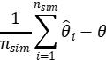
Empirical standard error | 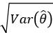 | 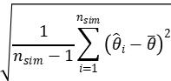
Mean square error | 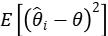 | 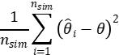
Coverage |  | 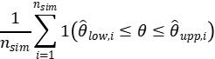
Power |  | 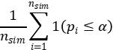
model-based standard error | $\sqrt{E⌊\hat{Var}\left(\hat{θ}\right)⌋}$ | $\sqrt{\frac{1}{n_{sim}}\sum_{1}^{n_{sim}}{}\hat{Var}({\hat{θ}}_{i})}$

Where $θ$ represents the parameter under investigation, $\hat{θ}$being the estimate of that parameter, $\underline{θ}$ being the mean value of the estimate, $n_{sim}$ being the number of simulations (in this study, 86,88), being the p-value of estimate $i$ and $α$ being the significance level (5%).

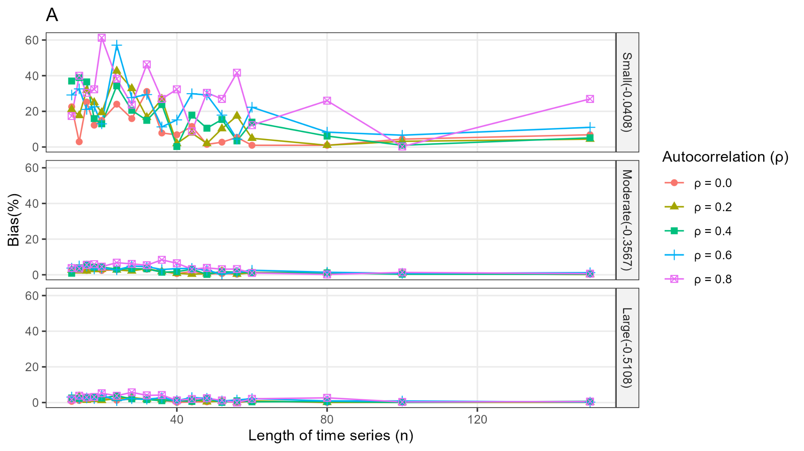
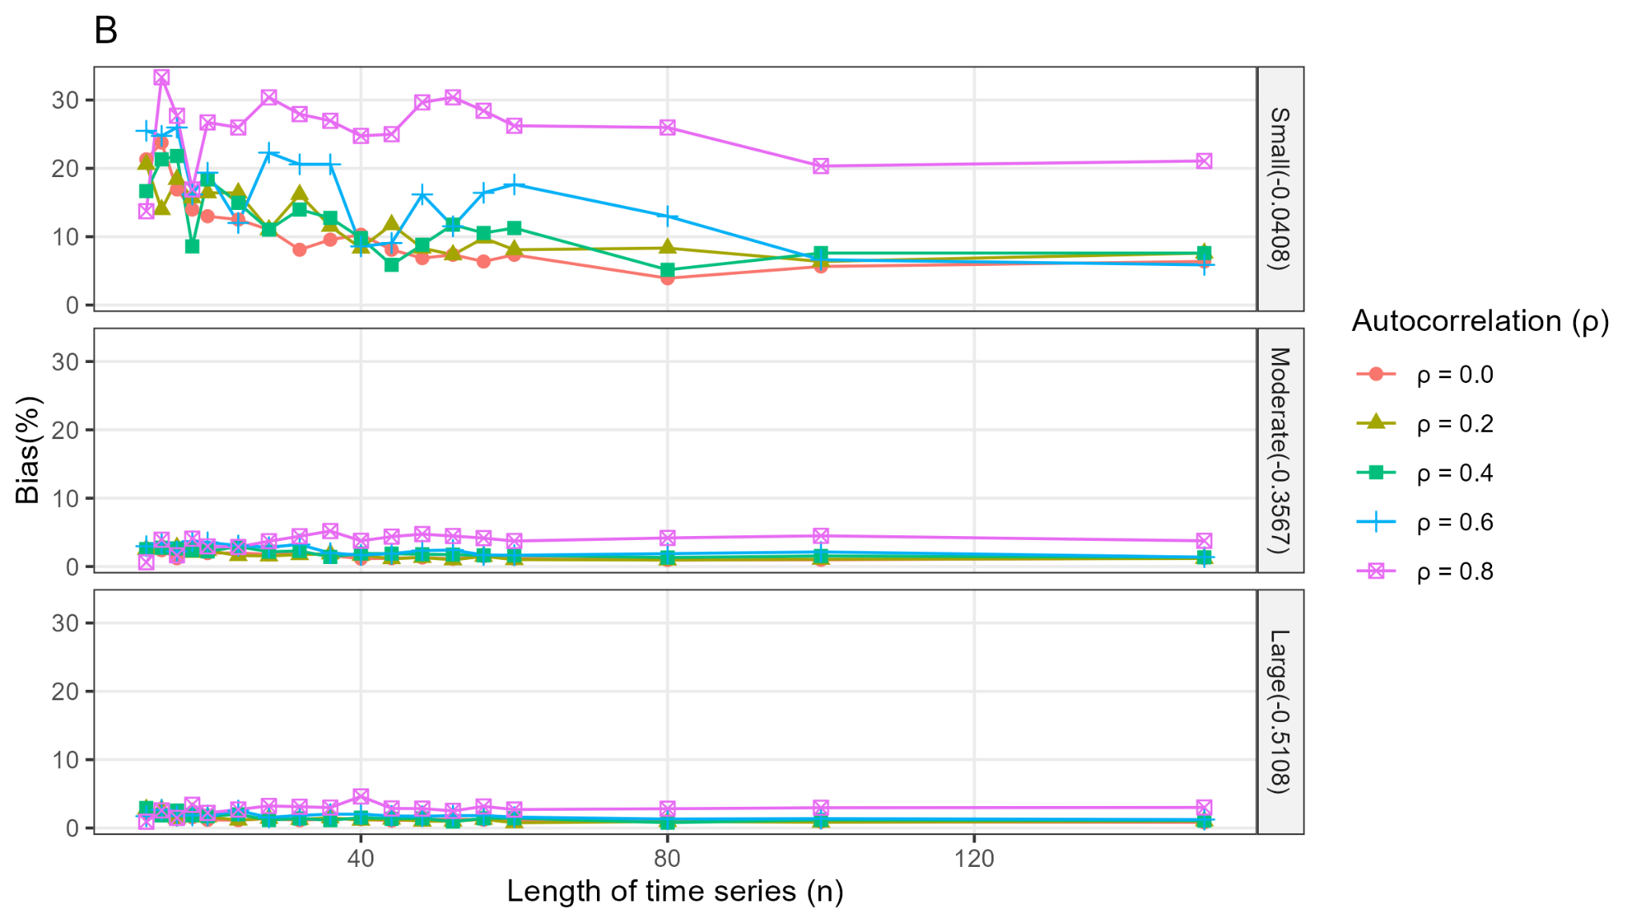
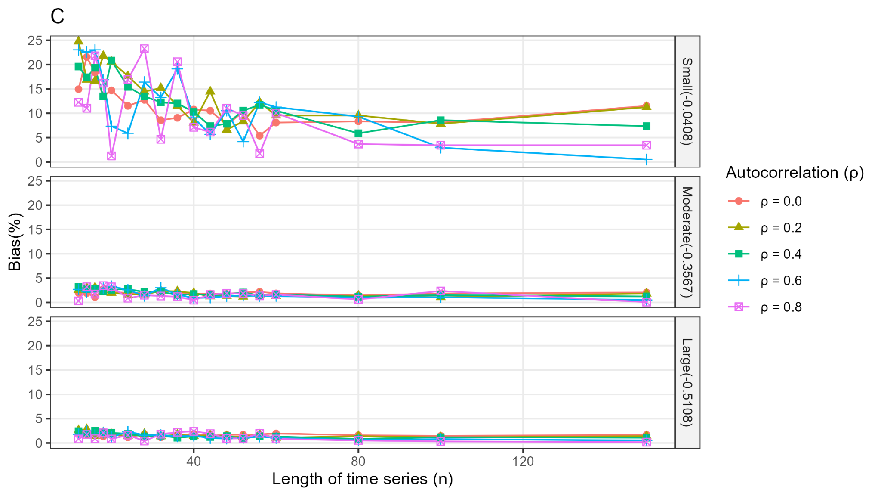
Supplementary Figure 1. Results from the multivariable negative binomial regression (A), controlled interrupted time series model (B), and controlled interrupted time series model with control-series autocorrelation fixed at 0.4 (C).

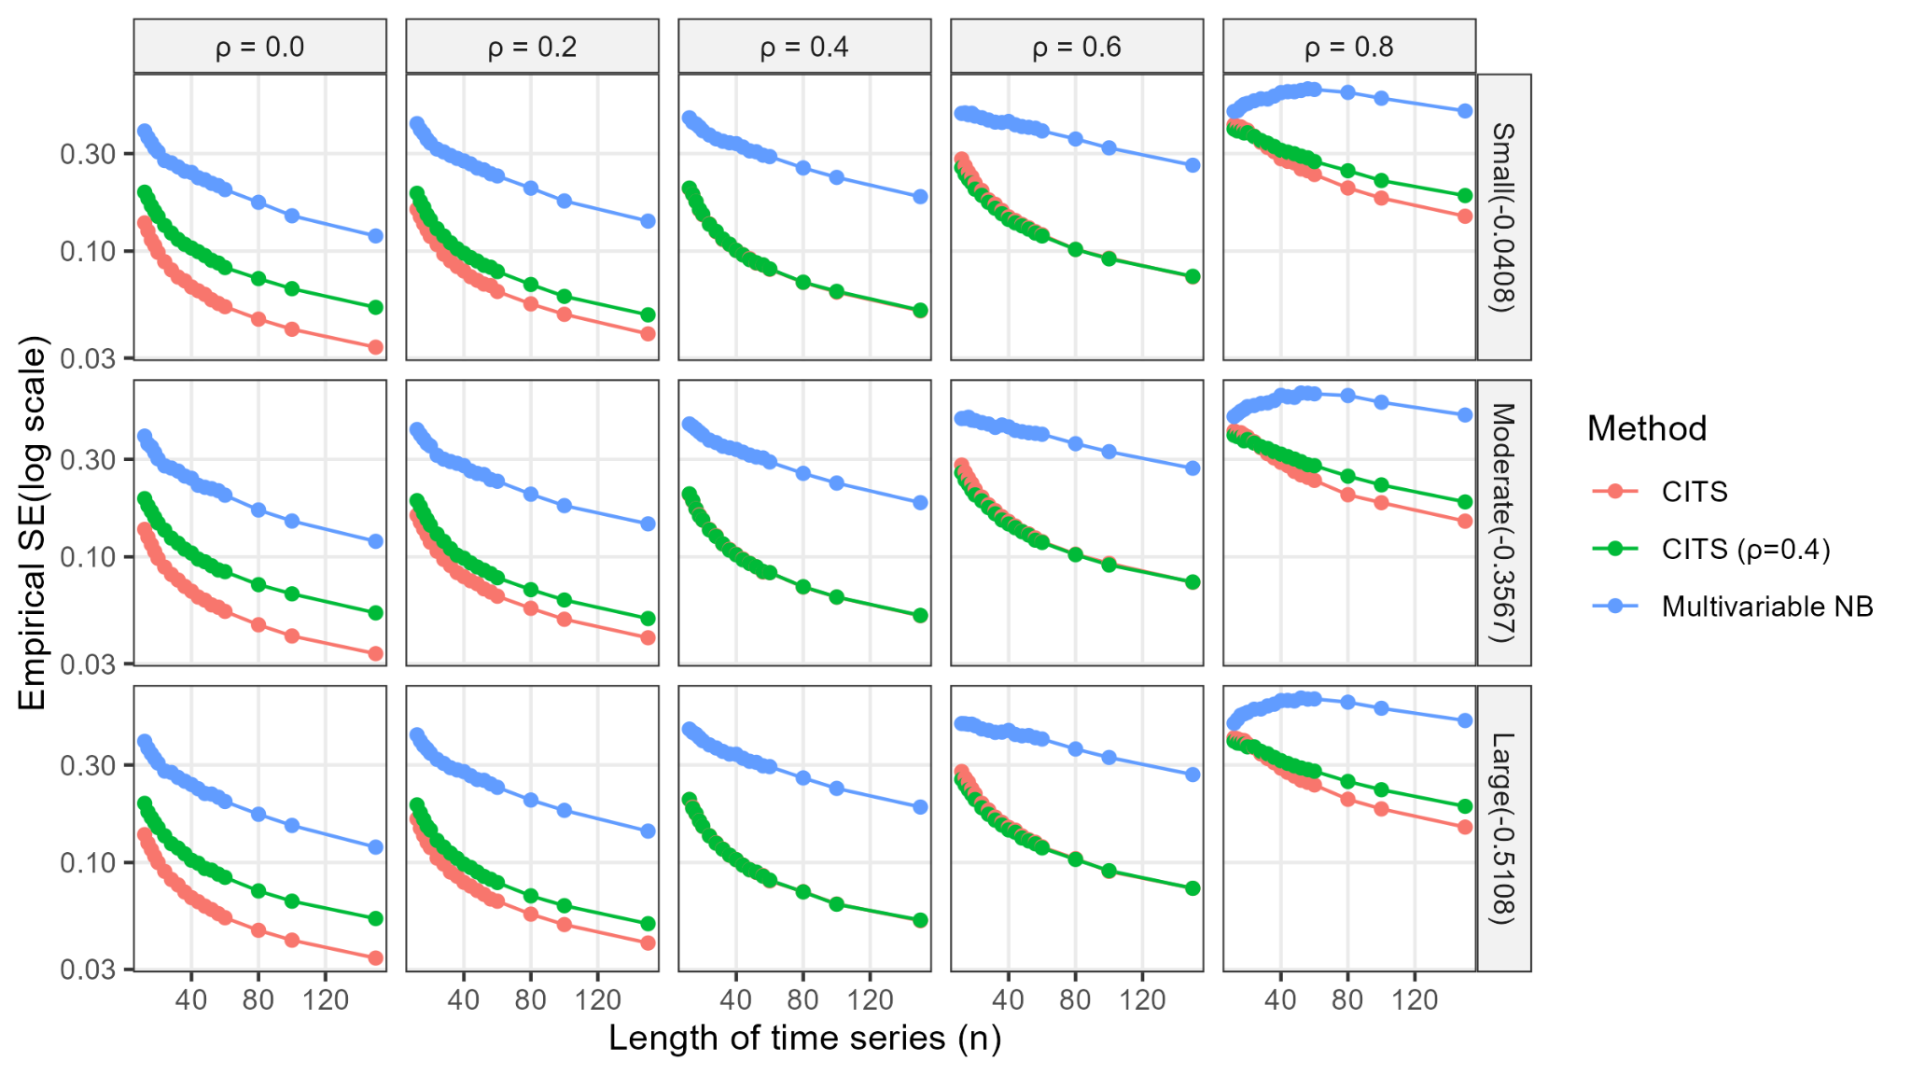
Supplementary Figure 2. Empirical standard errors from the multivariable negative binomial regression (multivariable NB) and the controlled interrupted time series (CITS) model in which the control series shares the exact lag-1 autocorrelation magnitude (ρ) with the outcome series (Yt), as well as CITS with fixed autocorrelation (ρ = 0.4).

